
Proposition for tutored project
Study of the chemical profile of Cannabis sativa using a metabolomic approach

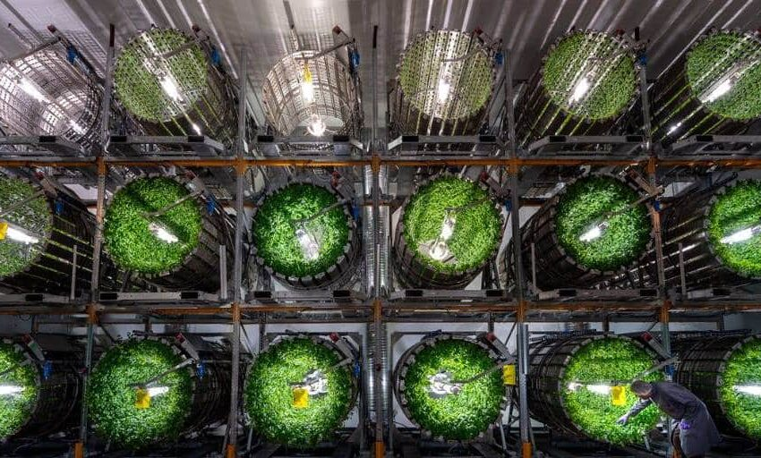
Company :
Futura Gaïa Technologies

Context :
Futura Gaïa Technologies is a pioneering company specializing in soil-based vertical farming through its GiGrow® rotative cultivation systems. By integrating advanced agronomy with innovative technology, Futura Gaïa offers sustainable farming solutions that optimize space, water, and energy, enabling year-round, pesticide-free crop production in controlled environments.

Cannabis sativa, a valuable plant for both medicinal and recreational uses, is especially prized for its CBD content in indoor farming. However, there is a lack of information on how Futura Gaïa's cultivation practices affect the plant's overall metabolic profile, including key compounds like CBD, and more globally, cannabinoids.

Objectives:
- Conduct a literature review to gain a deeper understanding of key molecules of interest found in Cannabis sativa plants and their biosynthesis processes.
- Develop and implement a protocol to analyze the metabolic profile of Cannabis sativa using advanced metabolomic technologies in collaboration with Avignon University. A special focus is expected on cannabinoids.
- Bonus objective: Identify or gather insights into metabolomic markers that indicate the effects of the rotative cultivation system.
Contact: cedric.dresch@futuragaia.com

